Coot Builder’s Order Form


Name: _____________________________________________________________________________

Address: ___________________________________________________________________________

State/Prov: _______________________________ Zip/Postal Code: ___________________________

Phone: _________________________________ E-Mail: ____________________________________

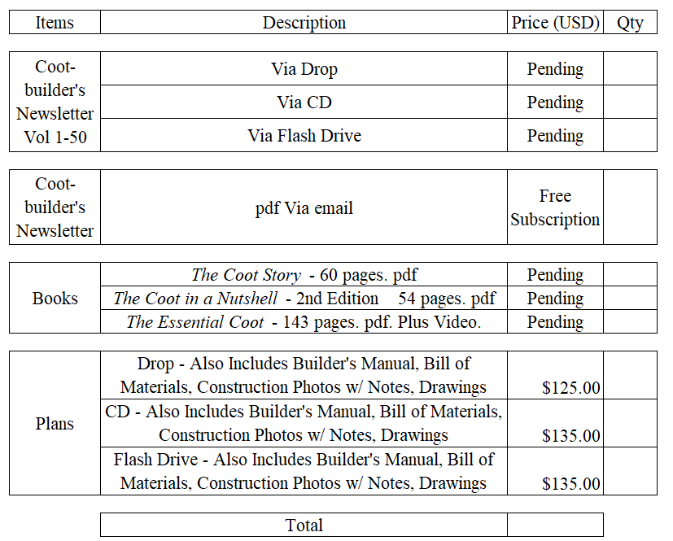

NOTE: All prices are in U.S. funds. Payment may be made by US Check, Money Order, or Credit Card.

Check & money order payments: Complete and print this form, and mail with payment to:

Andrew Wayne
1511 Fell Ave. N.E.
Huntsville, AL 35811

Credit Card order payments: Complete and email this form, and phone Andrew Wayne at:

Ph: (256) 585-8965
email: svtanstaafl2@gmail.com

